AI ASSIGNMENT-11.4
NAME:D.ANKITHA
ROLL NO:2503A51L09
Data Structures with AI: Implementing Fundamental Structures
Lab Objectives:
• Use AI to assist in designing and implementing fundamental data
structures in Python.
• Learn how to prompt AI for structure creation, optimization, and documentation.
• Improve understanding of Lists, Stacks, Queues, Linked Lists, Trees,
Graphs, and Hash Tables.
• Enhance code quality with AI-generated comments and performance
suggestions.
Task 1: Implementing a Stack (LIFO)
• Task: Use AI to help implement a Stack class in Python with the
following operations: push(), pop(), peek(), and is_empty().
• Instructions:
o Ask AI to generate code skeleton with docstrings.
o Test stack operations using sample data.
o Request AI to suggest optimizations or alternative implementations (e.g., using collections.deque).
AI Generated skeleton code with Docstrings:
CODE:
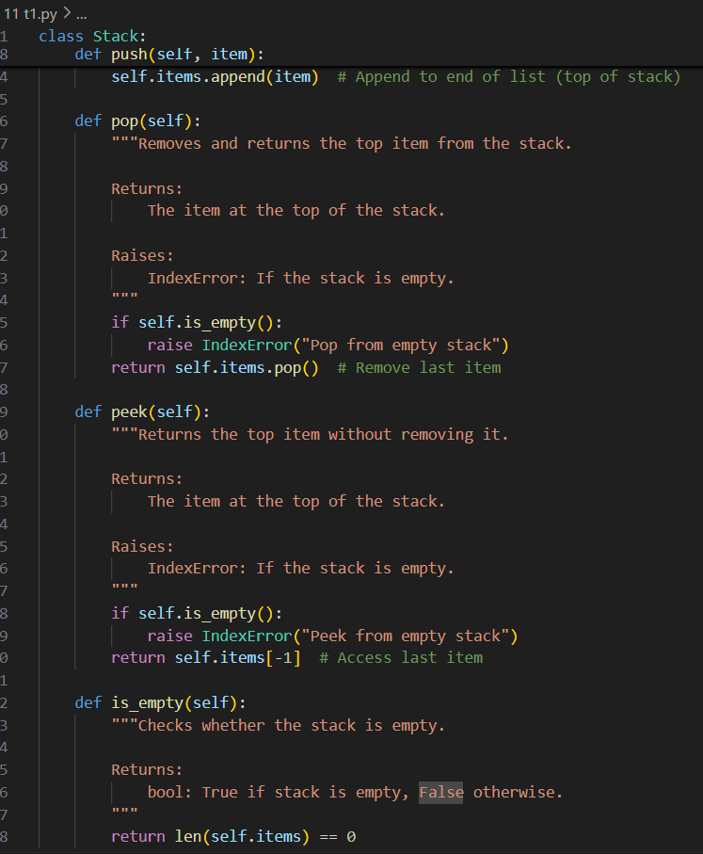
Output:
Testing stack operation with sample Data:
CODE:
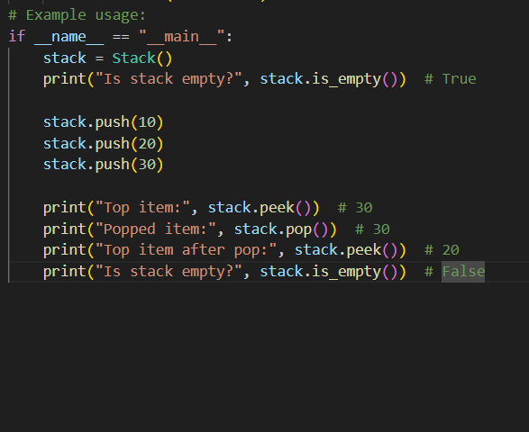
Output:
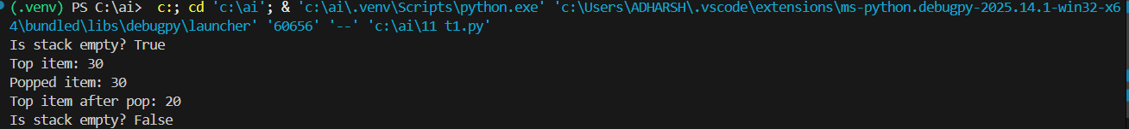
Alternative Implementation:
CODE:
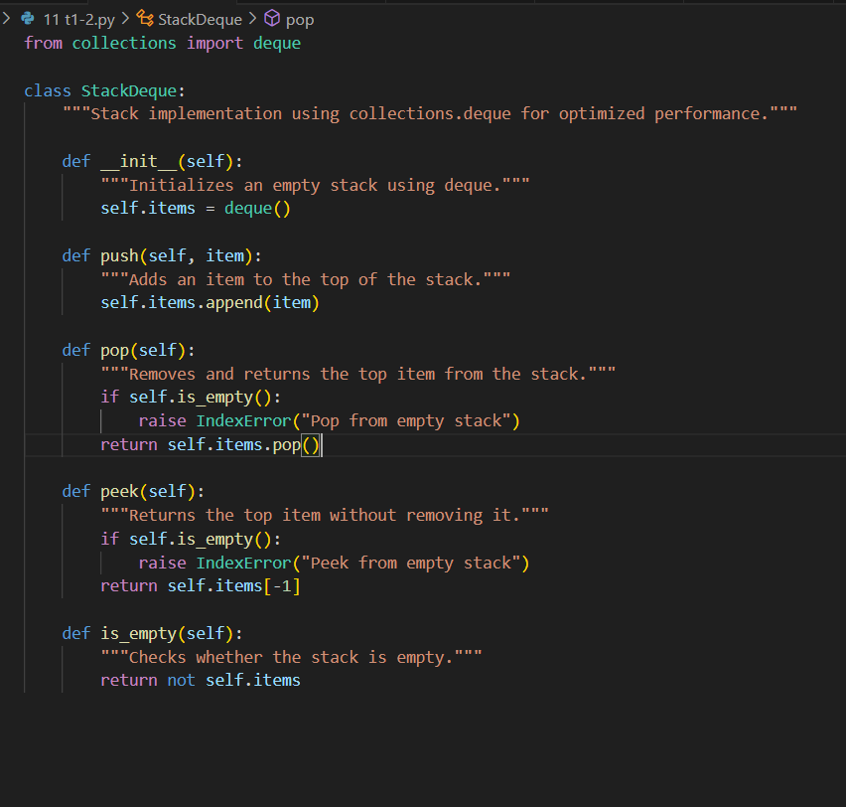
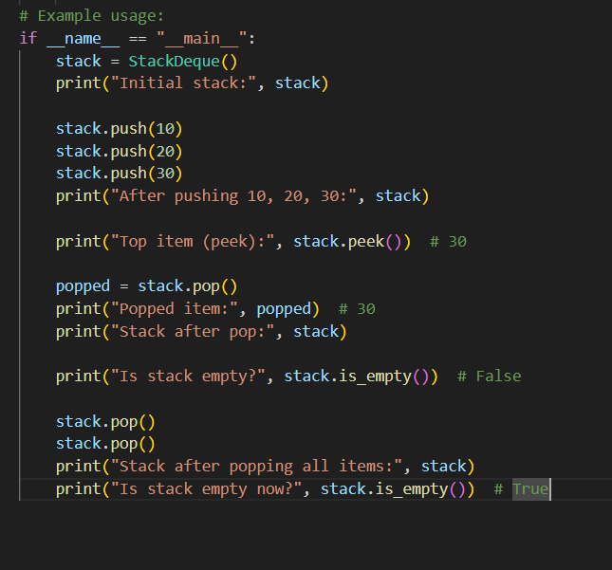
OUTPUT:
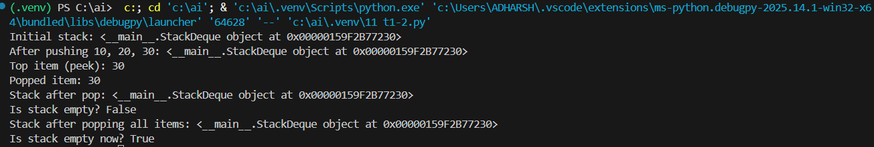
OBSERVATION:
Code Skeleton Generation
- AI-generated Stack class includes:
  - push(item): Adds an item to the top of the stack.
  - pop(): Removes and returns the top item.
  - peek(): Returns the top item without removing it.
  - is_empty(): Checks if the stack is empty.
Docstrings clearly describe each method’s purpose and behavior.
Modular design makes it easy to adapt for classroom use or enhancements.
AI recommends using collections.deque for performance:
- Deque-based stack offers O(1) time complexity for append and pop operations.
- More memory-efficient and faster than using a list for large-scale operations.
Task 2: Queue Implementation with Performance Review
- Task: Implement a Queue with enqueue(), dequeue(), and is_empty() methods.
- Instructions:
  - First, implement using Python lists.
  - Then, ask AI to review performance and suggest a more efficient implementation (using collections.deque).
Prompt: Review performance and suggest a more efficient implementation (using collections.deque).
Code without AI:
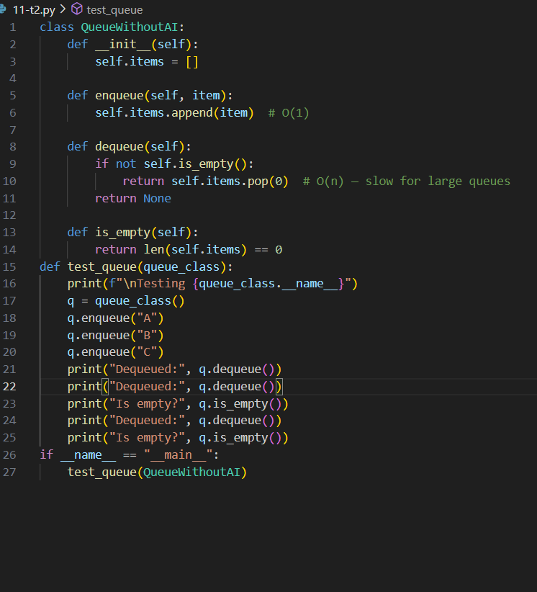
Output:
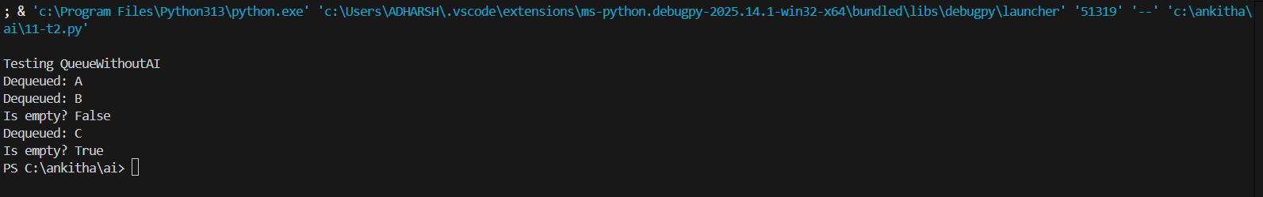
Code with AI:
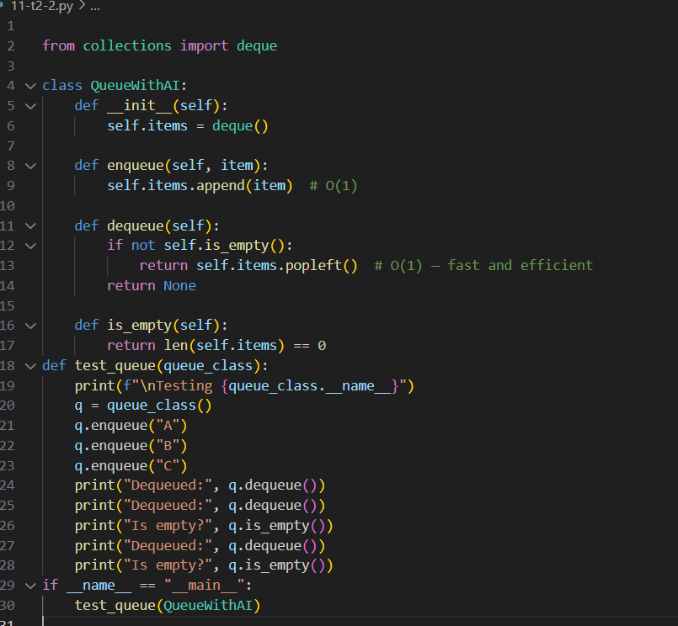
Output:
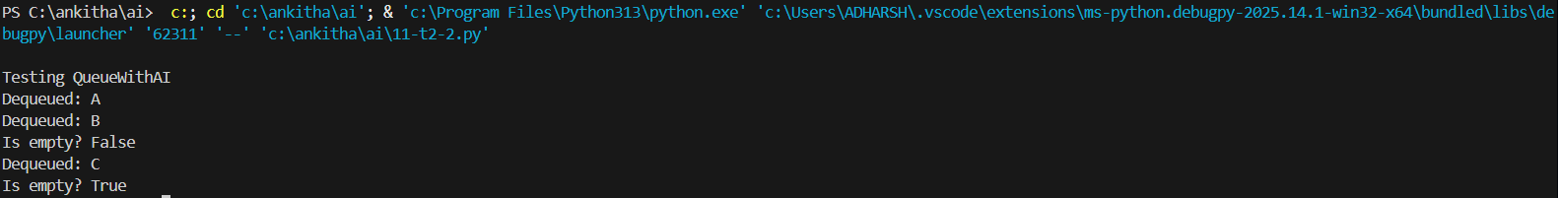
Observation:
Here the manual took more time to execute and ai generate code took less time to execute
Ai generated code looks more put-together than manually written one.
Task 3: Singly Linked List with Traversal
- Task: Implement a Singly Linked List with operations: insert_at_end(), delete_value(), and traverse().
- Instructions:
  - Start with a simple class-based implementation (Node, LinkedList).
  - Use AI to generate inline comments explaining pointer updates (which are non-trivial).
  - Ask AI to suggest test cases to validate all operations.
Prompt:
Generate inline comments explaining pointer updates and Suggest test cases to validate all operations
Code without AI:
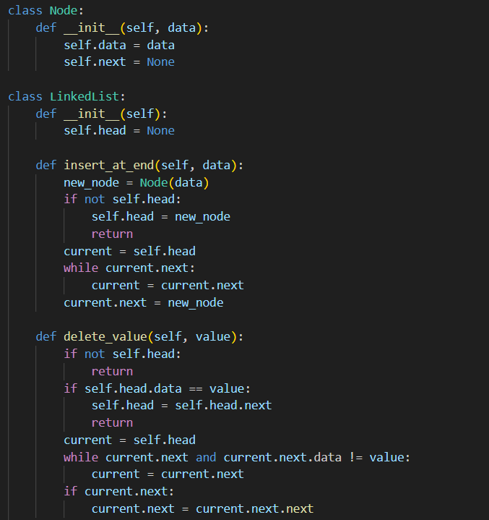

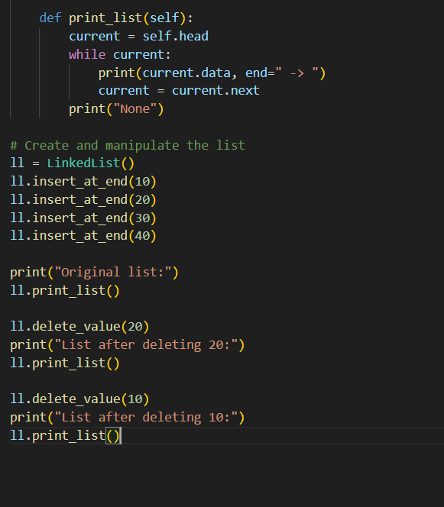
Output:
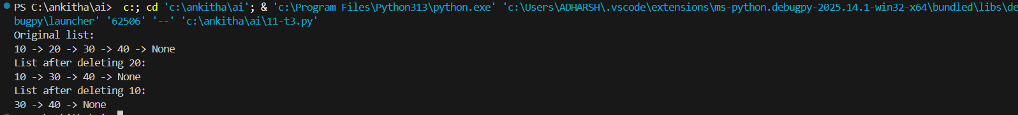
Code with AI:
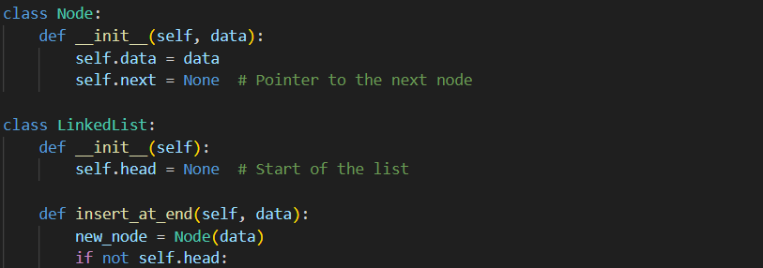

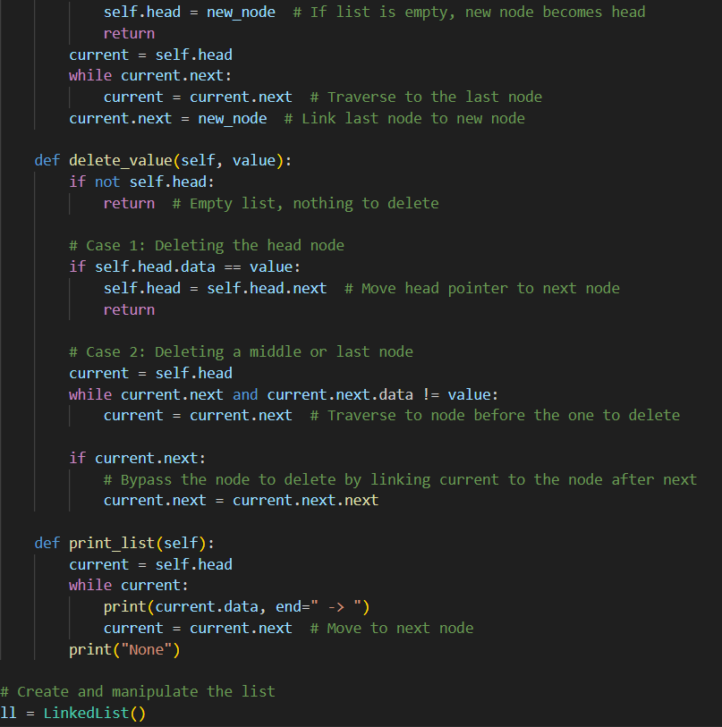
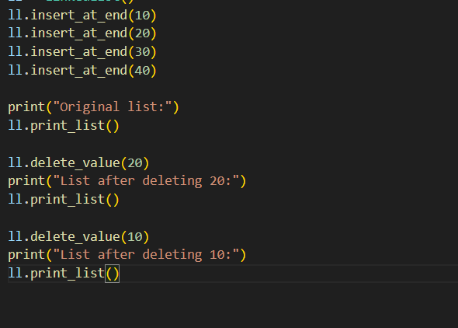
Output:
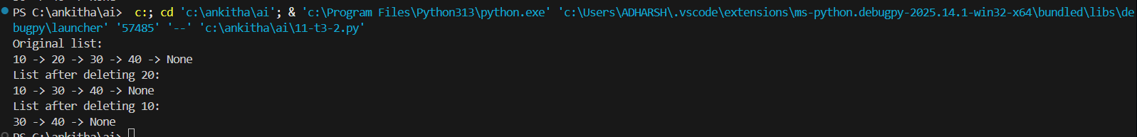
Observation:
AI generated clear comments explaining the logic of insertions and deletions and Suggested test cases to validate all operations.
Task 4: Binary Search Tree (BST)
- Task: Implement a Binary Search Tree with methods for insert(), search(), and inorder_traversal().
- Instructions:
  - Provide AI with a partially written Node and BST class.
  - Ask AI to complete missing methods and add docstrings.
  - Test with a list of integers and compare outputs of search() for present vs absent elements.
- Expected Output:
  - A BST class with clean implementation, meaningful docstrings, and correct traversal output.
Code:
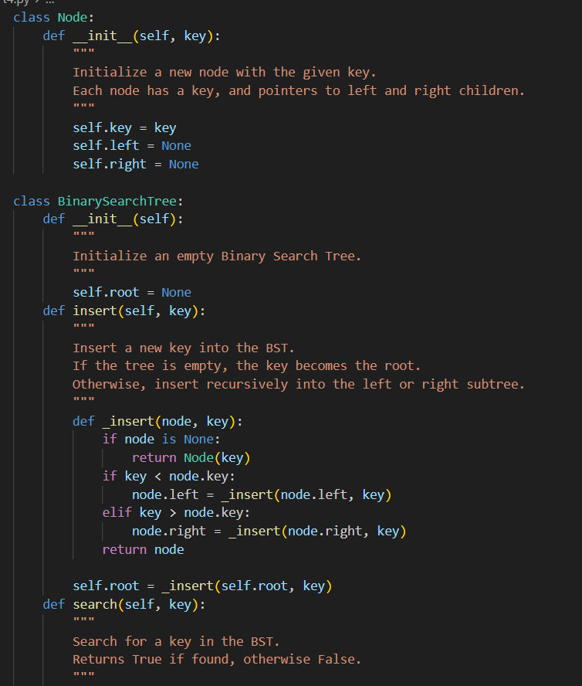
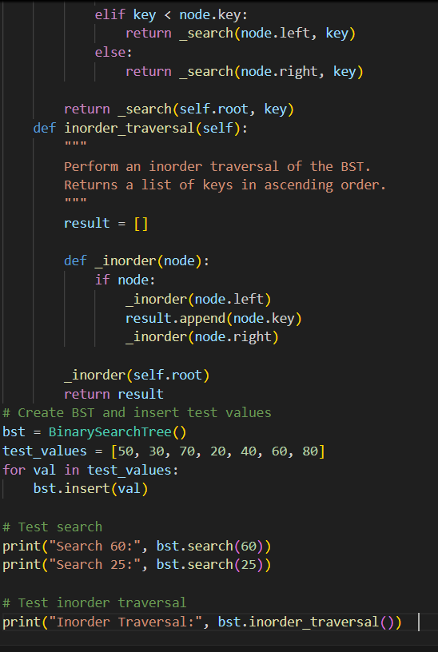
Output:
Observation:
To implement a Binary Search Tree (BST) in Python with three core functionalities:
insert(key): Add a new key to the tree.
search(key): Check if a key exists in the tree.
inorder_traversal(): Return all keys in sorted (ascending) order.
Node Class: Represents each node with a key and pointers to left and right children.
BinarySearchTree Class:
- Uses a recursive approach for insert() and search() to maintain BST properties.
- inorder_traversal() performs a depth-first traversal to return sorted keys.

